Before reading:
- What are the origins of Carnival? Do you know why people celebrate carnival?
- What are, according to you, the best costumes?
- Are you going to celebrate carnival? Do you already have a costume?
- What are some differences between Brazilian/Summer carnival and Dutch carnival?

Ultimate guide to celebrating Dutch Carnival in the Netherlands
BY DAVE BRETT

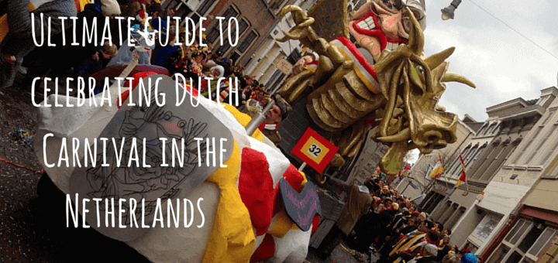

1 If there is one thing the Dutch love to do, that’s getting together, partying with friends and drinking a large amount of beer. Dutch Carnival is one massive excuse to make this all happen for a week of straight fun. Prepare yourself and you too can get in on the action.
2 This blog post aims to focus on tips for international visitors that wish to take part in this traditional Dutch event.
3 Maybe you’re an expat who lives in Amsterdam or an exchange student in Utrecht, I hope that you take part in the Carnaval and find this Ultimate guide to celebrating Dutch Carnival in the Netherlands useful and informative.

What makes the Dutch Carnival so special?
6 Whilst on study exchange at Tilburg University I stumbled across this traditional event that I never quite understood at first.
7 I had never heard about this incredible celebration of Dutch Carnaval until I moved to The Netherlands. After three years of taking part I can happily say it’s been one of the craziest weeks of my Dutch exchange experience in the Netherlands, and if you can be sure to take part.
8 The Dutch in the south has grown up with being around Carnaval all their life and embrace it without question each year. If you don’t get invited along with a group of Dutchies you can easily be left out of the action.
9 Not that it’s a hidden secret or anything it’s just a way of life and the locals seem to miss out on the fact that Internationals have completely no clue about what’s going on. If you happen to be an international in The Netherlands you might have seen carnaval promotions and wondered what it is all about and dare to get involved.
10 I remember when I first asked a Dutch friend if I could join him to his local village to celebrate carnival. At first he was kind of surprised I wanted to join, but in the end, he comes around to the idea and thought it was great that I wanted to join him.
11 After a few phone calls I was in and we had an incredibly awesome time. Don’t be afraid to ask your local Dutch friends from the south if you can join them for carnaval celebrations. See if they will be up for adopting you and showing you the ropes of the event.
12 And a message to all the Dutchies: If you know a fun international friend living in the Netherlands, be sure to take them on board and introduce them to the Dutch Carnaval way of life. Dutch Carnaval can be confusing for International students on exchange in the south of the Netherlands.

13 It’s up to you to make this week incredible, by stepping up, committing to the Carnaval spirit and going all out with embracing the celebration. By wanting to make it the best carnival of your life you will easily find other Dutchies also wanting to do the same. You can decide to remain clueless and remain in your home city, from the outside, you won’t “get it or “understand it”, but don’t be this person, jump in and embrace it!
14 Buy a costume, get ready for some beers and crazy Dutch music. Prepare to travel around the South of The Netherlands and fully enjoy the crazy world that is the Dutch Carnaval. Make sure you have a loaded OV-chipkaart travel card to pay for your train tickets well in advance.

What is Dutch Carnaval?
15 Carnival in the Netherlands is called Carnaval and it’s traditionally celebrated in the Catholic region of the Netherlands in the south around the provinces of North Brabant and Limburg. Carnival starts on Sunday and follows through to Ash Wednesday. _8_ many students use the Carnaval to party for a whole week and will often start from the Thursday through to the Wednesday. Dates each year change depending on ash Wednesday.

Saturday – Maastricht or Tilburg

16 Depending on where you are in the Netherlands be sure to spend Saturday in either Tilburg (Brabant) or Maastricht (Limburg). Each city has a different way of celebrating carnaval. Personally, I loved Tilburg as I’m biased and studied in the city.
17 I have heard that Maastricht also puts on a good show. Saturday is the day to experience the opening ceremony when the prince of Carnaval gets the key to the city in the morning at the central train station. The parade floats during the day are worth checking out. Then you can attempt to visit as many bars as possible into the early hours of the morning.
18 If you spend your Saturday in Tilburg you can get a free tie to stamp off each bar you visit and follow a route, sort of like a pub crawl.
19 Both cities have a different style of doing Carnaval, so it’s up to you where you choose to party. In my opinion, Tilburg is the best out of the two.
20 You can find a Bar called Carpe Noctem that will be hosting a Carnaval party for international students (I*ESN) on Saturday, worth checking out if you’re in town and want some cheap student beers. _12_ all the bars (Even ones that remain closed throughout the year) will open up.
21 They will be playing crazy Dutch music and the party transforms and takes over the whole city. Many party tents around the city pop up and beer are endlessly flowing from keg taps non-stop on almost every corner.
22 The city will never look the same again and it’s a unique experience to be a part of this event.
Source: https://traveldave.co.uk/ultimate-guide-celebrating-dutch-carnival-netherlands/

After reading:

- There are 9 words in bold. Do you know the definition of these words? Write the definition in the box next to the word.

- massive
- expat
- Dutchies
- committing
- clueless
- biased
- tie
- key

- Wat is the overall tone of the article?
- What point of view does the author write from?
- Kies bij _8_ in alinea 15 het juiste antwoord uit de gegeven mogelijkheden. word fits the gap
- Although
- Similarly
- Firstly
- Consequently

- What type of article is this?
- News article
- Diary entry
- Blog post
- Interview

- What have you learnt about the author? Mention at least two things.

- What advice does he give to people unknown to carnival? Mention at least two things.

- Kies bij _12_ in alinea 20 het juiste antwoord uit de gegeven mogelijkheden. word fits the gap
- Not
- Mostly
- Unfortunately
- Sadly

- Do you know why they celebrate carnival only in the south of the Netherlands?

